Write UP

Comparative Study of Countries

**Step 1:** Open **Tableau**

**Step 2:** On the home page, under **Connect,** under **to a file,** click **Excel.**

**Step 3:** Browse and connect to the **Global Financial Development Database Jul2018**

**Step 4:** Drag and drop **Data July 2018** tables to the canvas area.

**Step 5:** Click on Add button to connect **Insurance Sample Dataset** Excel file.

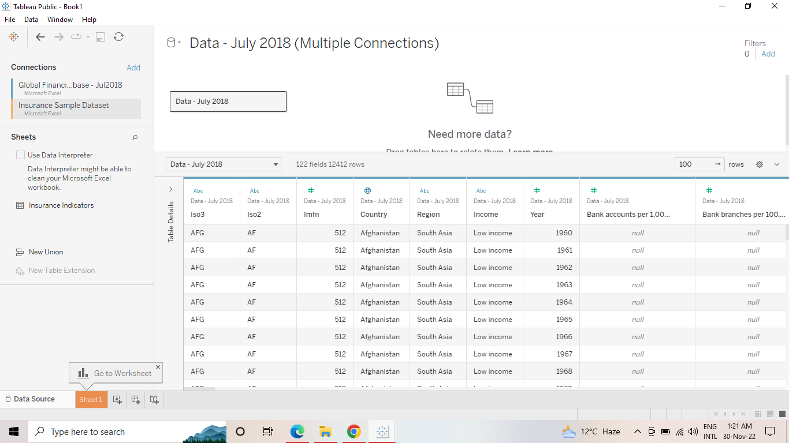

**Step 6:** Go to Sheet one and rename it as MAP.

**Step 7:** To Create a **MAP**, drag **Country** from **Insurance Sample Dataset** and put on Detail Mark card and then go to automatic and click map. Then drag Income from **Global Financial Development Database** to filer and select all and click on show filter. Drag **Income** to Colour Mark Card and **Country Code** to text Mark card.

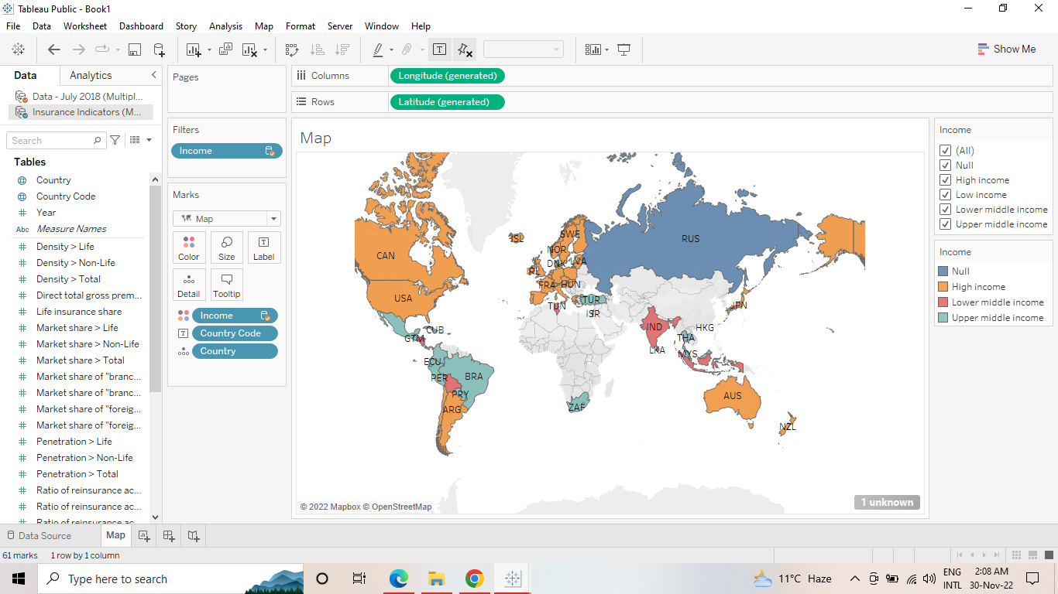

**Step 8:** Create 2 Parameters , One for **Select Year** and Another **Select Category.**

**Step 9:** To create Parameter go to Down key below Filter button in Data panel, And click on Create Parameter. For Year parameter click on Date datatype and for Select Category Click on String Data type.

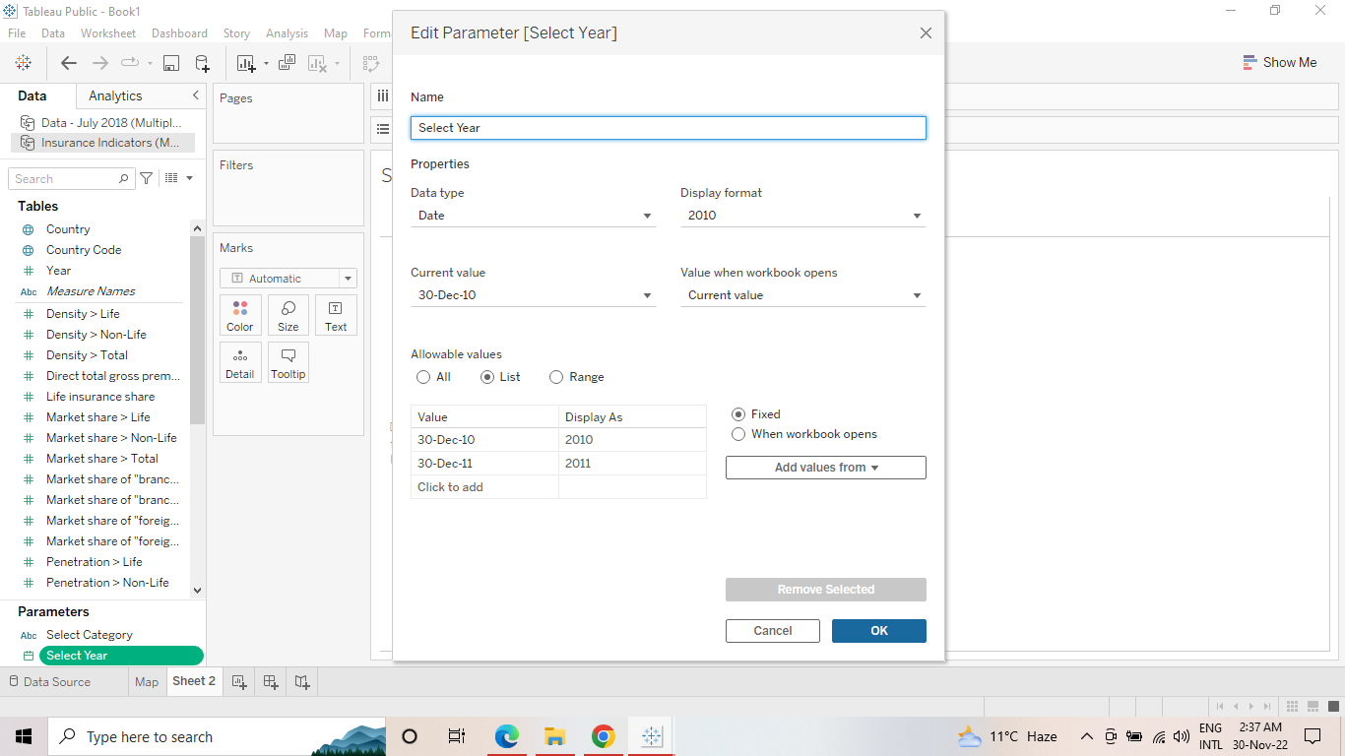

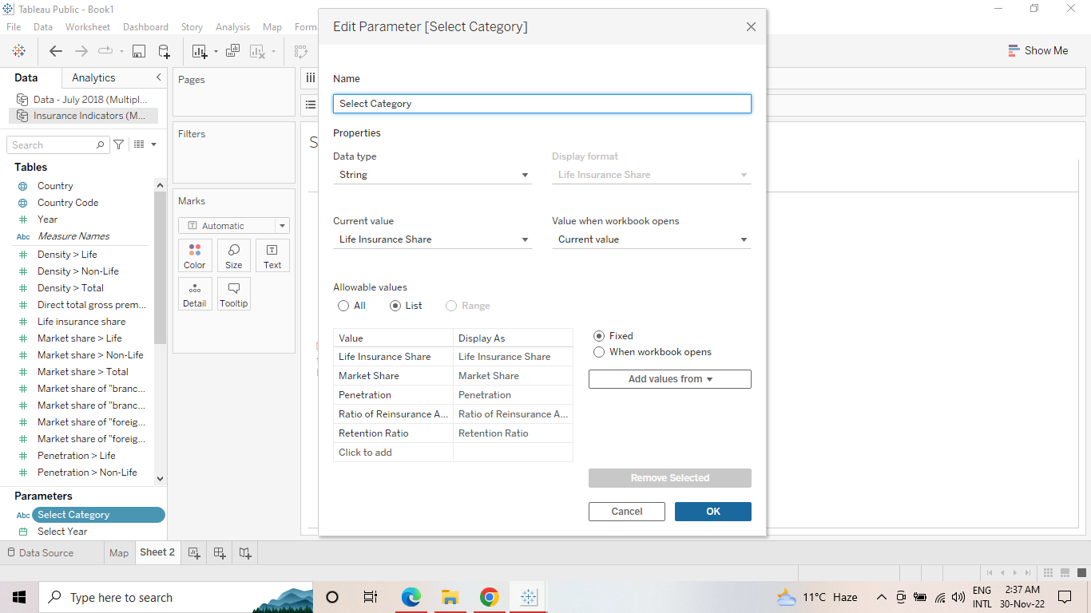

**Step 10:** Create **Calculated Field:** To Select Category, Categorial CY(Current year) and Categorial PY(Previous Year),Growth %.

**Step 11**: Click on Analysis Pane , and then Calculated Field and do calculations for the following.

Select Category is for : to Select Category Parameter Categorial CY

Categorial PY

Growth : For Growth %

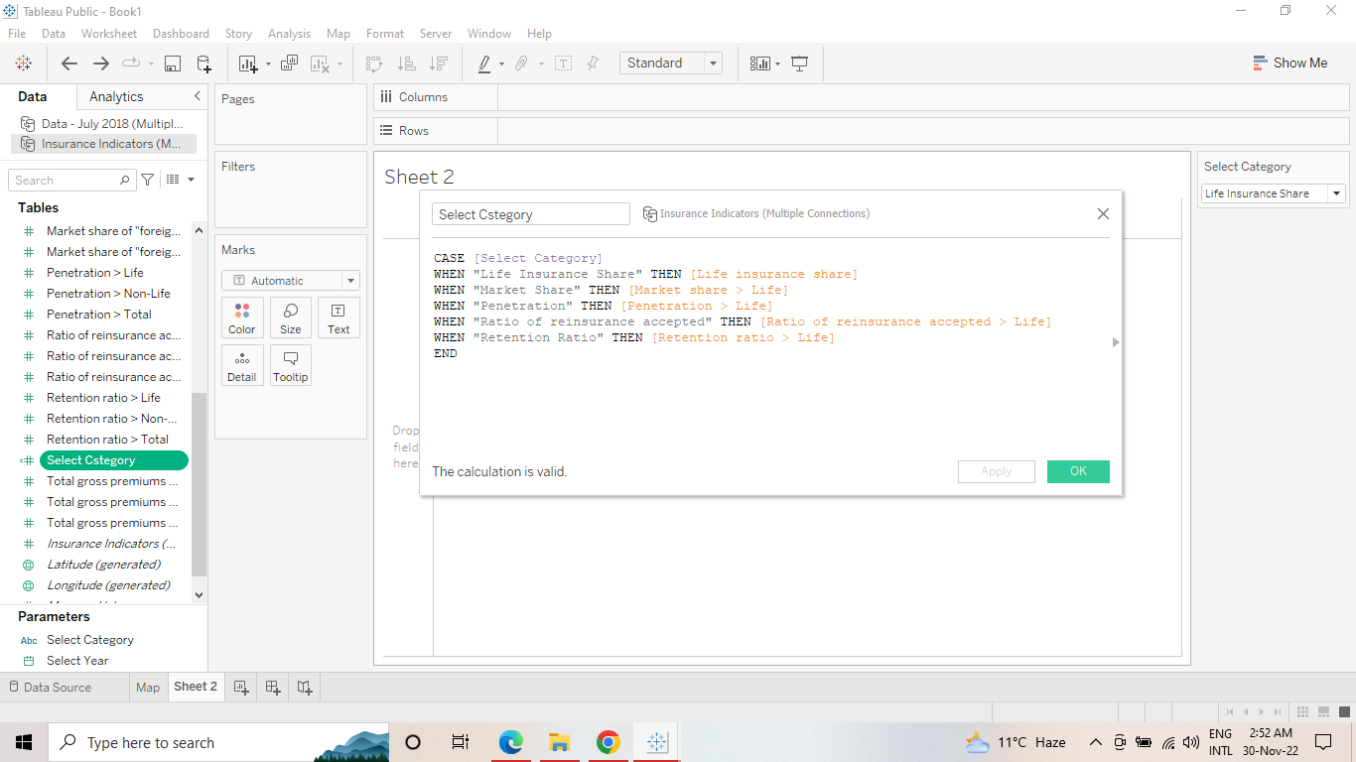

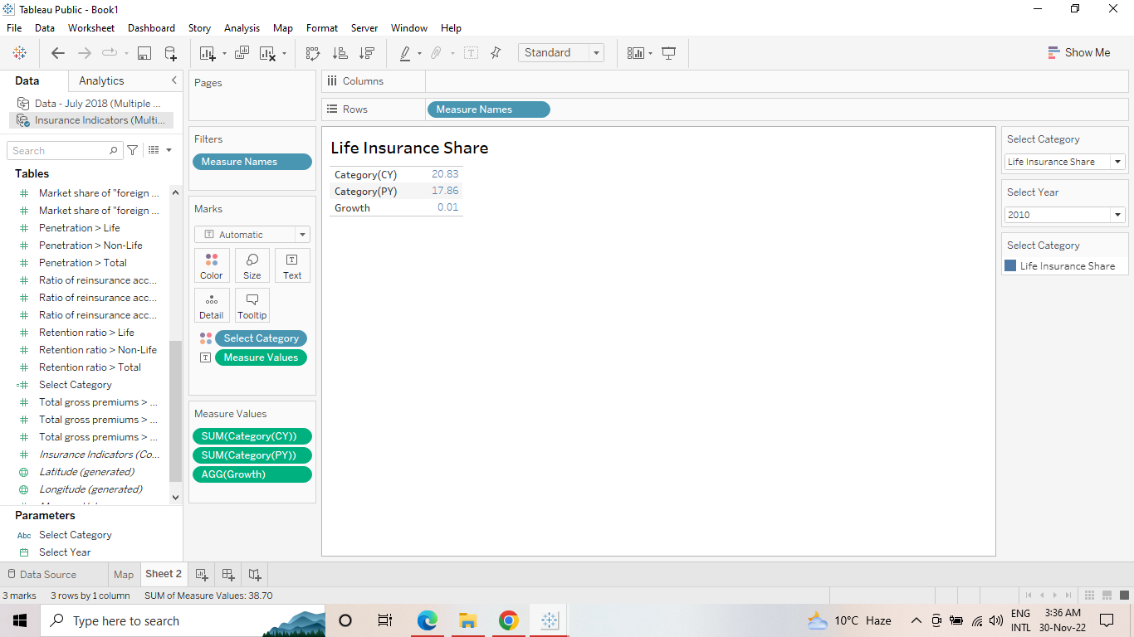

**Step 12:** To create a growth indicator:

Create 2 Calculated Field: Growth Colour and Growth Indicator

**Step 13:** Growth Indicator Visualization : Go to New Sheet and rename it Growth Indicator

Click on Parameters and Show Parameter.

Drag Growth Colour to Colour and Growth Indicator To text.

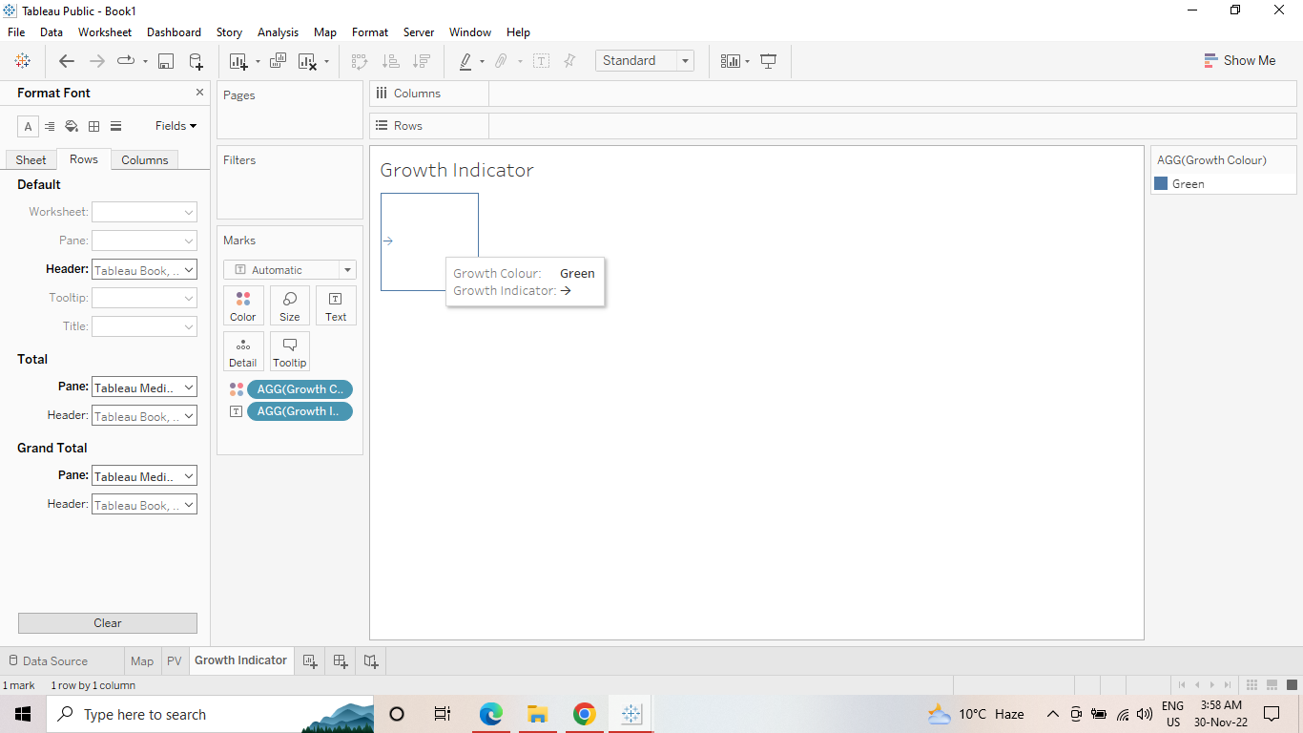

**Step 14:** To Create Trend Chart: Go to New sheet and rename it Trend Chart. Click on Parameters and Show Parameter.

Drag Year to Columns and Select Category Measure to Rows.

Year to Pages [To make a Motion Chart] and click on Show history and Trails.

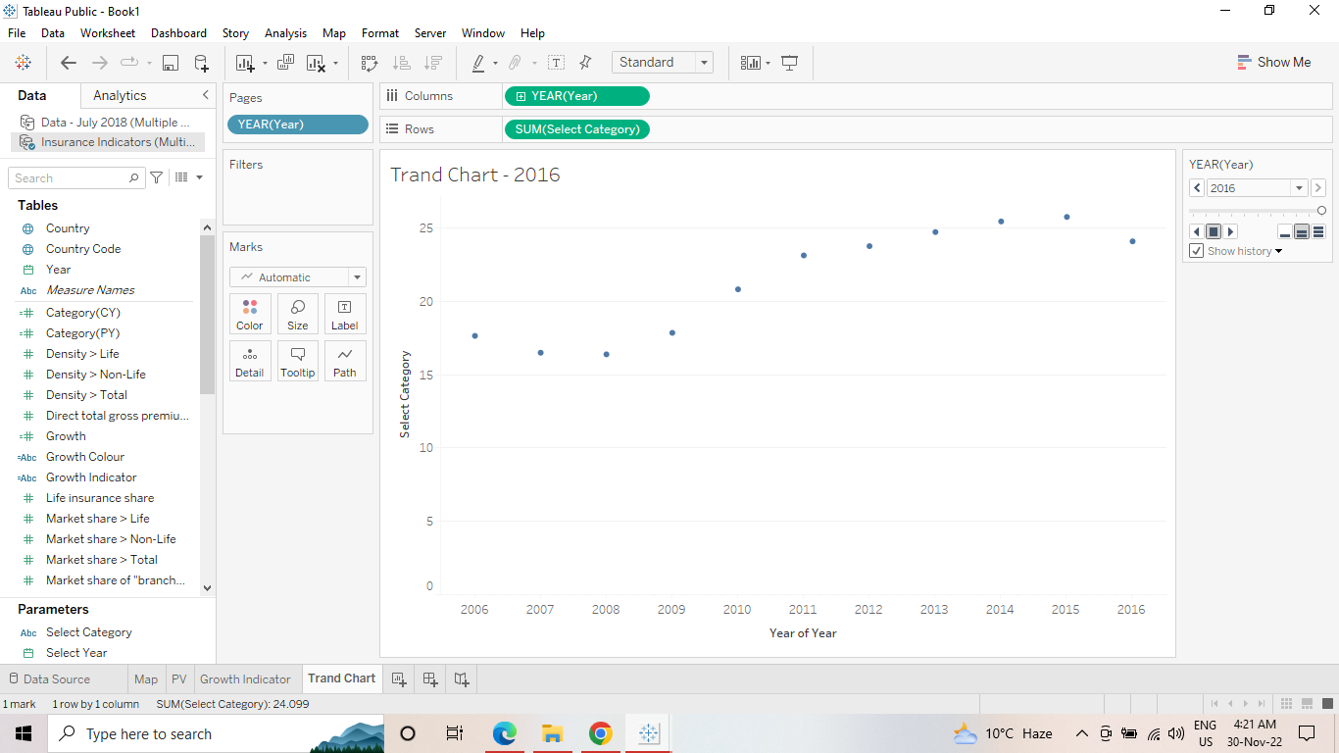

**Step 14:** Create a Dashboard: Click on Dashboard button . Go to Size and click Automatic.

Go to Objects and click on Horizontal, Then Vertical , and then Horizontal, Drag Map to sheet , From Objects drag web Page to sheet.

Then Go to Dashboard , Click Action -> add action -> go to URL -> edit action-> Source sheet -> Map and Run action -> Select

And add URL in URL bar.

And also add all sheet to Dashboard.

**Step 15:** Dashboard ready to slideshow.

